01. Master in Read Mode (only one byte) :-  /* Master in Read Mode*/  #include<avr/io.h>  void i2c_init (void){  TWSR = 0X00; // set prescaler bits to zero  TWBR = 0x47; // SCL frequency is 50K for XTAL = 8Mhz  TWCR = 0x04; // enable TWI module  }  void i2c_start(void){  TWCR = ( 1 << TWINT ) | ( 1 << TWSTA ) | ( 1 << TWEN );  while ((TWCR & ( 1 << TWINT ) ) == 0) ;  }  void i2c_write(unsigned char data){  TWDR = data ;  TWCR = (1<<TWINT) | (1<<TWEN); // enable the transmission  while ((TWCR & ( 1 << TWINT ) ) == 0); // polling e.g checking TWINT flag to check whether START condition transmitted succesfully  }  unsigned char i2c_read(unsigned char last){  if ( last == 0 ) // If want to read more than 1 byte  TWCR = (1<<TWINT) | (1<<TWEN) | (1<<TWEA);  else // else read only one byte  TWCR = (1<<TWINT) | (1<<TWEN);  while ((TWCR & ( 1 << TWINT ) ) == 0);  return TWDR ;  }  void i2c_stop(){  TWCR = ( 1 <<TWINT )|( 1 << TWEN) | ( 1<< TWSTO);  }  int main(void){  unsigned char i = 0 ;  DDRD = 0xFF; // PORTD is output  i2c_init(); // initialse TWI for master mode  i2c_start(); // transmit start condition  i2c_write(0b11010001); // transmitt Slave address + R(1) (SLA+R means to master is reading )  i = i2c_read(1); // read only 1 byte  PORTD= i; // show byte in PORTD  i2c_stop(); // transmitt stop condition  while(1);  return 0;  } | 02. Master in Write Mode (only one byte) :-  /* Master in Write Mode*/  #include<avr/io.h>  void i2c_init (void)  {  TWSR = 0X00; // set prescaler bits to zero  TWBR = 0x47; // SCL frequency is 50K for XTAL = 8Mhz  TWCR = 0x04; // enable TWI module  }  void i2c_start(void)  {  TWCR = ( 1 << TWINT ) | ( 1 << TWSTA ) | ( 1 << TWEN );  while ((TWCR & ( 1 << TWINT ) ) == 0) ;  }  void i2c_write(unsigned char data)  {  TWDR = data ;  TWCR = (1<<TWINT) | (1<<TWEN); // enable the transmission  while ((TWCR & ( 1 << TWINT ) ) == 0); // polling e.g checking TWINT flag to check whether START condition transmitted succesfully  }  void i2c_stop()  {  TWCR = ( 1 <<TWINT )|( 1 << TWEN) | ( 1<< TWSTO);  }  int main(void)  {  i2c_init(); // initialse TWI for master mode  i2c_start(); // transmit start condition  i2c_write(0b11010000); // transmitt Slave address + W0 (SLA+W means to master is writing )  i2c_write(0b10101010); // transmitt data  i2c_stop(); // transmitt start condition  while(1);  return 0;  }
-: I2C Protocol :-
03. Slave in Read Mode (only one byte) :-  /* Slave in Read mode*/  #include<avr/io.h>  void i2c_initslave (unsigned char slaveaddress)  {  TWCR = 0x04; // enable TWI module by setting TWEN flag  TWAR = slaveaddress; // set slave address  TWCR = (1<<TWINT) | (1<<TWEN) | (1<<TWEA); // init TWI module  }  void i2c_listen()  {  while ((TWCR & ( 1 << TWINT ) ) == 0); // wait to be addressed by master  }  unsigned char i2c_read(unsigned char last)  {  if ( last == 0 ) // If want to read more than 1 byte  TWCR = (1<<TWINT) | (1<<TWEN) | (1<<TWEA);  else // else read only one byte  TWCR = (1<<TWINT) | (1<<TWEN);  while ((TWCR & ( 1 << TWINT ) ) == 0);  return TWDR ;  }  int main(void)  {  DDRD = 0xFF; // PORTD is output  i2c_initslave(0b11010001); // initiate TWI module as slave with address = 0b11010001  i2c_listen(); // listen to be addressed  PORTD = i2c_read(1); // read only 1 byte  while(1);  return 0;  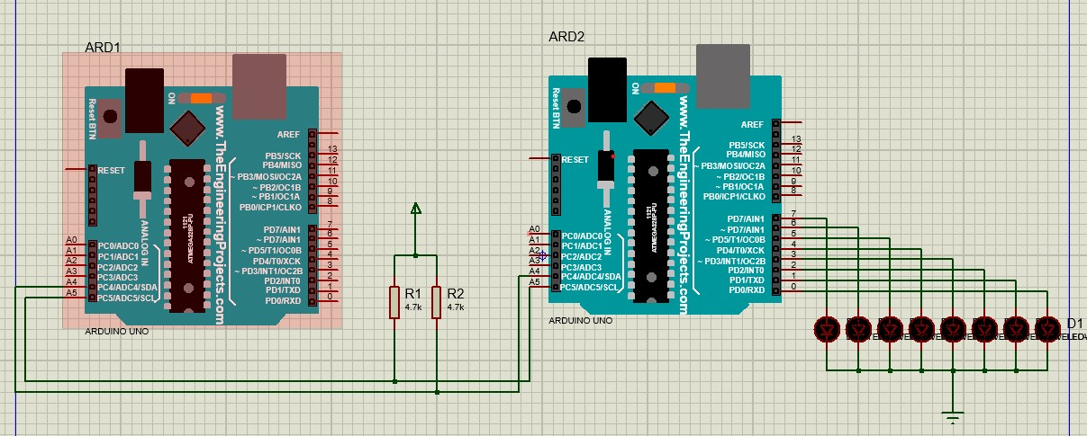  } | 04. Slave in Write Mode (only one byte) :-  /* Slave in write mode*/  #include<avr/io.h>  void i2c_initslave (unsigned char slaveaddress)  {  TWCR = 0x04; // enable TWI module by setting TWEN flag  TWAR = slaveaddress; // set slave address  TWCR = (1<<TWINT) | (1<<TWEN) | (1<<TWEA); // init TWI module  }  void i2c_listen()  {  while ((TWCR & ( 1 << TWINT ) ) == 0); // wait to be addressed by master  }  void i2c_send(unsigned char data)  {  TWDR = data ; // copy data to TWDR  TWCR = ( 1 << TWINT ) | ( 1 << TWEN ); // start transmission  while ((TWCR & ( 1 << TWINT ) ) == 0) ; // wait to complete  }  int main(void)  {  i2c_initslave(0b11010001); // initiate TWI module as slave with address = 0b11010001  i2c_listen(); // listen to be addressed  i2c_send('U'); //transmitt letter  while(1); // stay here forever  return 0;  }
05. Master in Read Mode (one byte at a time) :-  /* Master in Read Mode*/  #include<avr/io.h>  void i2c_init (void){  TWSR = 0X00; // set prescaler bits to zero  TWBR = 0x47; // SCL frequency is 50K for XTAL = 8Mhz  TWCR = 0x04; // enable TWI module  }  void i2c_start(void){  TWCR = ( 1 << TWINT ) | ( 1 << TWSTA ) | ( 1 << TWEN );  while ((TWCR & ( 1 << TWINT ) ) == 0) ;  }  void i2c_write(unsigned char data){  TWDR = data ;  TWCR = (1<<TWINT) | (1<<TWEN); // enable the transmission  while ((TWCR & ( 1 << TWINT ) ) == 0); // polling e.g checking TWINT flag to check whether START condition transmitted succesfully  }  unsigned char i2c_read(unsigned char last){  if ( last == 0 ) // If want to read more than 1 byte  TWCR = (1<<TWINT) | (1<<TWEN) | (1<<TWEA);  else // else read only one byte  TWCR = (1<<TWINT) | (1<<TWEN);  while ((TWCR & ( 1 << TWINT ) ) == 0);  return TWDR ;  }  void i2c_stop(){  TWCR = ( 1 <<TWINT )|( 1 << TWEN) | ( 1<< TWSTO);  }  int main(void){  unsigned char i = 0 ;  DDRD = 0xFF; // PORTD is output  i2c_init(); // initialse TWI for master mode  L1:  i2c_start(); // transmit start condition  i2c_write(0b11010001); // transmitt Slave address + R(1) (SLA+R means to master is reading )  i = i2c_read(0); // 0 for read multiple bytes  PORTD= i; // show byte in PORTD  i2c_stop(); // transmitt stop condition  for(volatile unsigned long i=0; i<100000; i++);  goto L1;  while(1);  return 0;  } | 06. Master in Write Mode (one byte at a time) :-  /* Master in Write Mode*/  #include<avr/io.h>  void i2c_init (void){  TWSR = 0X00; // set prescaler bits to zero  TWBR = 0x47; // SCL frequency is 50K for XTAL = 8Mhz  TWCR = 0x04; // enable TWI module  }  void i2c_start(void){  TWCR = ( 1 << TWINT ) | ( 1 << TWSTA ) | ( 1 << TWEN );  while ((TWCR & ( 1 << TWINT ) ) == 0) ;  }  void i2c_write(unsigned char data){  TWDR = data ;  TWCR = (1<<TWINT) | (1<<TWEN); // enable the transmission  while ((TWCR & ( 1 << TWINT ) ) == 0); // polling e.g checking TWINT flag to check whether START condition transmitted succesfully  }  void i2c_stop(){  TWCR = ( 1 <<TWINT )|( 1 << TWEN) | ( 1<< TWSTO);  }  int main(void){  volatile uint8_t shift=0;  i2c_init(); // initialise TWI for master mode  L1:  i2c_start(); // transmit start  i2c_write(0b11010000); // transmitt Slave address + W0 (SLA+W means to master is writing )  i2c_write(1<<shift); // transmitt data  i2c_stop(); // transmitt start condition  for(volatile long i=0; i<100000; i++);  shift++;  if(shift==8) shift=0;  goto L1;  while(1);  return 0;  }

07. Slave in Read Mode (one byte at a time) :-  /* Slave in Read mode*/  #include<avr/io.h>  void i2c_initslave (unsigned char slaveaddress)  {  TWCR = 0x04; // enable TWI module by setting TWEN flag  TWAR = slaveaddress; // set slave address  TWCR = (1<<TWINT) | (1<<TWEN) | (1<<TWEA); // init TWI module  }  void i2c_listen()  {  while ((TWCR & ( 1 << TWINT ) ) == 0); // wait to be addressed by master  }  unsigned char i2c_read(unsigned char last)  {  if ( last == 0 ) // If want to read more than 1 byte  TWCR = (1<<TWINT) | (1<<TWEN) | (1<<TWEA);  else // else read only one byte  TWCR = (1<<TWINT) | (1<<TWEN);  while ((TWCR & ( 1 << TWINT ) ) == 0);  return TWDR ;  }  int main(void)  {  DDRD = 0xFF; // PORTD is output  i2c_initslave(0b11010001); // initiate TWI module as slave with address = 0b11010001  L1:  i2c_listen(); // listen to be addressed  PORTD = i2c_read(0); // 0 for read multiple bytes  goto L1;  while(1);  return 0;  } | 08. Slave in Write Mode (one byte at a time) :-  /* Slave in write mode*/  #include<avr/io.h>  volatile uint8_t shift=0;  void i2c_initslave (unsigned char slaveaddress)  {  TWCR = 0x04; // enable TWI module by setting TWEN flag  TWAR = slaveaddress; // set slave address  TWCR = (1<<TWINT) | (1<<TWEN) | (1<<TWEA); // init TWI module  }  void i2c_listen()  {  while ((TWCR & ( 1 << TWINT ) ) == 0); // wait to be addressed by master  }  void i2c_send(unsigned char data)  {  TWDR = data ; // copy data to TWDR  TWCR = ( 1 << TWINT ) | ( 1 << TWEN ); // start transmission  while ((TWCR & ( 1 << TWINT ) ) == 0) ; // wait to complete  }  int main(void)  {  L1:  i2c_initslave(0b11010001); // initiate TWI module as slave with address = 0b11010001  i2c_listen(); // listen to be addressed  i2c_send(3<<shift); //transmitt letter  shift++;  if(shift==8) shift=0;  goto L1;  while(1); // stay here forever  return 0;  }
09. Master in Write Mode (Multiple bytes) :-  /* Master in Write Mode*/  #include<avr/io.h>  void i2c_init (void){  TWSR = 0X00; // set prescaler bits to zero  TWBR = 0x47; // SCL frequency is 50K for XTAL = 8Mhz  TWCR = 0x04; // enable TWI module  }  void i2c_start(void){  TWCR = ( 1 << TWINT ) | ( 1 << TWSTA ) | ( 1 << TWEN );  while ((TWCR & ( 1 << TWINT ) ) == 0) ;  }  void i2c_write(unsigned char data){  TWDR = data ;  TWCR = (1<<TWINT) | (1<<TWEN); // enable the transmission  while ((TWCR & ( 1 << TWINT ) ) == 0); // polling e.g checking TWINT flag to check whether START condition transmitted succesfully  }  void i2c_stop(){  TWCR = ( 1 <<TWINT )|( 1 << TWEN) | ( 1<< TWSTO);  }  int main(void){  volatile uint8_t shift=0;  i2c_init(); // initialise TWI for master mode  L1:  i2c_start(); // transmit start  i2c_write(0b11010000); // transmitt Slave address + W0 (SLA+W means to master is writing )  i2c_write(1<<shift); // transmitt data  i2c_write(7<<shift); // transmitt data  i2c_stop(); // transmitt start condition  for(volatile long i=0; i<100000; i++);  shift++;  if(shift==8) shift=0;  goto L1;  while(1);  return 0;  } | 10. Slave in Read Mode (Multiple bytes) :-  /* Slave in Read mode*/  #include<avr/io.h>  void i2c_initslave (unsigned char slaveaddress)  {  TWCR = 0x04; // enable TWI module by setting TWEN flag  TWAR = slaveaddress; // set slave address  TWCR = (1<<TWINT) | (1<<TWEN) | (1<<TWEA); // init TWI module  }  void i2c_listen()  {  while ((TWCR & ( 1 << TWINT ) ) == 0); // wait to be addressed by master  }  unsigned char i2c_read(unsigned char last)  {  if ( last == 0 ) // If want to read more than 1 byte  TWCR = (1<<TWINT) | (1<<TWEN) | (1<<TWEA);  else // else read only one byte  TWCR = (1<<TWINT) | (1<<TWEN);  while ((TWCR & ( 1 << TWINT ) ) == 0);  return TWDR ;  }  int main(void)  {  DDRD = 0xFF; // PORTD is output  i2c_initslave(0b11010001); // initiate TWI module as slave with address = 0b11010001  L1:  i2c_listen(); // listen to be addressed  PORTD = i2c_read(0); // 0 for read multiple bytes  goto L1;  while(1);  return 0;  }
11. 16*2 LCD in 4 bit mode (Proteus) :-  #define command_high 4  #define command_low 0  #define data_high 5  #define data_low 1  #define slave_address 0x70  void i2c_init (void){  TWSR = 0X00; // set prescaler bits to zero  TWBR = 0x47; // SCL frequency is 50K for XTAL = 8Mhz  TWCR = 0x04; // enable TWI module  }  void i2c_start(void){  TWCR = ( 1 << TWINT ) | ( 1 << TWSTA ) | ( 1 << TWEN );  while ((TWCR & ( 1 << TWINT ) ) == 0) ;  }  void i2c_write(unsigned char data){  TWDR = data ;  TWCR = (1<<TWINT) | (1<<TWEN); // enable the transmission  while ((TWCR & ( 1 << TWINT ) ) == 0); // polling e.g checking TWINT flag to check whether START condition transmitted succesfully  }  void i2c_stop(){  TWCR = ( 1 <<TWINT )|( 1 << TWEN) | ( 1<< TWSTO);  }  ///////// ABOVE ARE THE I2C FUNCTIONS /////////////////  void lcd_init(){  send_command (0x02); // 4bit mode  //send_command (0x28); // Initialization of 16X2 LCD in 4bit mode  send_command (0x0E); // Display ON Cursor ON  send_command (0x06); // Auto Increment cursor  send_command (0x01); // Clear display  send_command (0x80); // Cursor at home position  }  void send_command(volatile uint8_t cmd){  volatile uint8_t high_nibble = cmd & 0xf0;  volatile uint8_t low_nibble = cmd << 4;  i2c_start(); // transmit start  i2c_write(slave_address); // transmitt Slave address + W0 (SLA+W means to master is writing )  i2c_write(high_nibble + command_high);  i2c_write(high_nibble + command_low);  i2c_write(low_nibble + command_high);  i2c_write(low_nibble + command_low);  i2c_stop(); // transmitt stop condition  delayMicroseconds(500);  } | void send_data(volatile uint8_t data1){  volatile uint8_t high_nibble = data1 & 0xf0;  volatile uint8_t low_nibble = data1 << 4;  i2c_start(); // transmit start  i2c_write(slave_address); // transmitt Slave address + W0 (SLA+W means to master is writing )  i2c_write(high_nibble + data_high);  i2c_write(high_nibble + data_low);  i2c_write(low_nibble + data_high);  i2c_write(low_nibble + data_low);  i2c_stop(); // transmitt stop condition  delayMicroseconds(50);  }  void lcd_string (char *str) /* Send string to LCD function */  {  int i;  for(i=0;str[i]!=0;i++) /* Send each char of string till the NULL */  {  send_data (str[i]); /* Call LCD data write */  }  }  int main(void){  i2c_init(); // initialise TWI for master mode  lcd_init(); // initialise the 16*2 LCD  lcd_string("Hello World!");  while(1);  return 0;  }  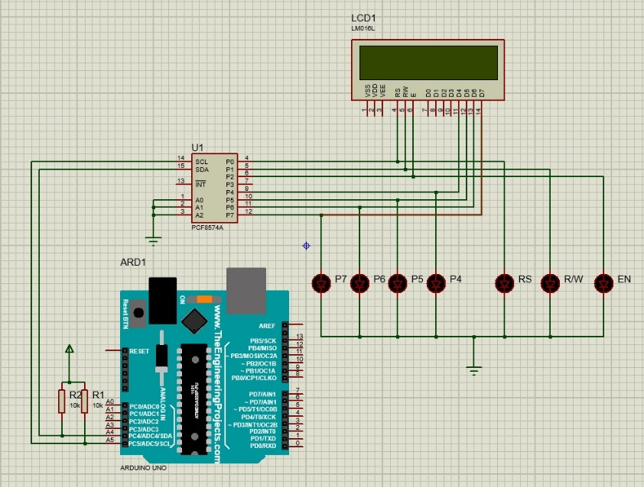  The only difference between wokwi and Proteus for this program is the delay(); function and its value
12. 16*2 LCD in 4 bit mode (Wokwi) :-  /* Note: in this program or any other program does not use the delay() function,if delay()  function is used, then overall program does not work, instead of it, use delayMicrosecond() */  void LCD_Init (void) /* LCD Initialize function */  {  delayMicroseconds(2000); /* LCD Power ON Initialization time >15ms */  LCD_Command (0x02); // 4bit mode  LCD_Command (0x28); // 4bit mode  LCD_Command (0x0C); //Display ON Cursor OFF  LCD_Command (0x06); // Auto Increment cursor  LCD_Command (0x01); // Clear display  LCD_Command (0x80); // Cursor at home position  }  void LCD_Command (volatile uint8_t cmnd)  {  PORTB = cmnd >> 4; /* Send upper nibble */  PORTD = 4;  delayMicroseconds(200);  PORTD = 0;  delayMicroseconds(200);  PORTB = cmnd & 0x0f;/* Send lower nibble */  PORTD = 4;  delayMicroseconds(200);  PORTD = 0;  delayMicroseconds(200);  }  void LCD_Char (volatile uint8_t data)  {  PORTB = data >> 4; /* Send upper nibble */  PORTD = 8 + 4;  delayMicroseconds(200);  PORTD = 8;  delayMicroseconds(200);  PORTB = data & 0x0f;/* Send lower nibble */  PORTD = 8 + 4;  delayMicroseconds(200);  PORTD = 8;  delayMicroseconds(200);  } | void LCD_String (volatile uint8_t *str) /* Send string to LCD function */  {  int i;  for(i=0;str[i]!=0;i++) /* Send each volatile uint8_t of string till the NULL */  {  LCD_Char (str[i]); /* Call LCD data write */  }  }  int main()  {  DDRD = 0x0c;  DDRB = 0x0f;  LCD_Init(); /* Initialization of LCD*/  LCD_String("Hello World!"); /* write string on 1st line of LCD*/  while(1); /* Infinite loop. */  return 0;  }  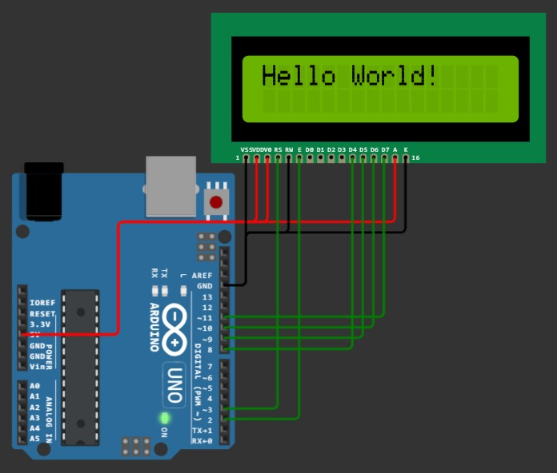

13. 16*2 LCD through I2C Protocol (Wokwi) :-  #define command_en_high 4 + 8 // RS=0, R/W=0, EN=1 (4), LED+ = 1 (8)  #define command_en_low 0 + 8 // RS=0, R/W=0, EN=0, LED+ = 1 (8)  #define data_en_high 1 + 4 + 8 // RS=1 (1), R/W=0, EN=1 (4), LED+ = 1 (8)  #define data_en_low 1 + 8 // RS=1 (1), R/W=0, EN=0, LED+ = 1 (8)  #define slave_address 0x27 << 1 // slave address of the I2C LCD  void i2c_init (void){  TWSR = 0X00; // set prescaler bits to zero  TWBR = 0x47; // SCL frequency is 50K for XTAL = 8Mhz  TWCR = 0x04; // enable TWI module  }  void i2c_start(void){  TWCR = ( 1 << TWINT ) | ( 1 << TWSTA ) | ( 1 << TWEN );  while ((TWCR & ( 1 << TWINT ) ) == 0) ;  }  void i2c_write(unsigned char data){  TWDR = data ;  TWCR = (1<<TWINT) | (1<<TWEN); // enable the transmission  while ((TWCR & ( 1 << TWINT ) ) == 0);  }  void i2c_stop(){  TWCR = ( 1 <<TWINT )|( 1 << TWEN) | ( 1<< TWSTO);  }  ///////////// ABOVE ARE THE I2C FUNCTIONS //////////////  ///////////// BELOW ARE THE LCD FUNCTIONS /////////////  void lcd_init(){  send_command (0x02); // 4bit mode  //send_command (0x28); // 4bit mode  send_command (0x0C); // Display ON Cursor OFF  send_command (0x06); // Auto Increment cursor  send_command (0x01); // Clear display  send_command (0x80); // Cursor at home position  }  void send_command(volatile uint8_t cmd){  volatile uint8_t high_nibble = cmd & 0xf0;  volatile uint8_t low_nibble = cmd << 4;  i2c_start(); // transmit start  i2c_write(slave_address); // transmitt Slave address + W0 (SLA+W means to master is writing ) | i2c_write(high_nibble + command_en_high);  i2c_write(high_nibble + command_en_low);  i2c_write(low_nibble + command_en_high);  i2c_write(low_nibble + command_en_low);  i2c_stop(); // transmit stop condition  delayMicroseconds(50);  }  void send_data(volatile uint8_t data1){  volatile uint8_t high_nibble = data1 & 0xf0;  volatile uint8_t low_nibble = data1 << 4;  i2c_start(); // transmit start  i2c_write(slave_address); // transmitt Slave address + W0 (SLA+W means to master is writing )  i2c_write(high_nibble + data_en_high);  i2c_write(high_nibble + data_en_low);  i2c_write(low_nibble + data_en_high);  i2c_write(low_nibble + data_en_low);  i2c_stop(); // transmitt stop condition  delayMicroseconds(50);  }  void lcd_string (char *str){  int i;  for(i=0;str[i]!=0;i++)  send_data (str[i]); /* Call LCD data write */  }  int main(void){  i2c_init(); // initialise TWI for master mode  lcd_init(); // initialise the 16*2 LCD  lcd_string("Hello World!");  while(1);  return 0;  }  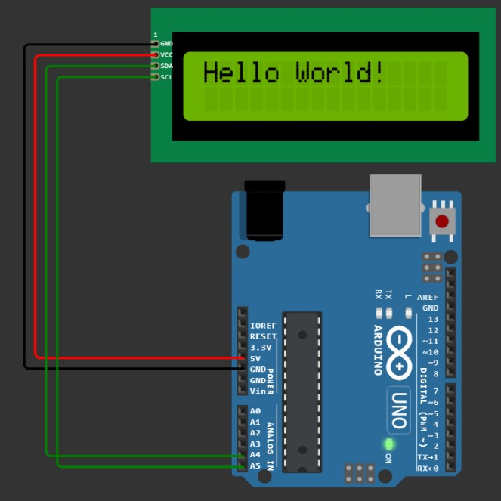
14. I2C Read & Write Program :-  #include<avr/io.h>  void i2c_init (void){  TWSR = 0X00; // set prescaler bits to zero  TWBR = 0x47; // SCL frequency is 50K for XTAL = 8Mhz  TWCR = 0x04; // enable TWI module  }  void i2c_start(void){  TWCR = ( 1 << TWINT ) | ( 1 << TWSTA ) | ( 1 << TWEN );  while ((TWCR & ( 1 << TWINT ) ) == 0) ;  }  void i2c_write(unsigned char data){  TWDR = data ;  TWCR = (1<<TWINT) | (1<<TWEN); // enable the transmission  while ((TWCR & ( 1 << TWINT ) ) == 0);  }  unsigned char i2c_read(unsigned char last){  if ( last == 0 ) // If want to read more than 1 byte  TWCR = (1<<TWINT) | (1<<TWEN) | (1<<TWEA);  else // else read only one byte  TWCR = (1<<TWINT) | (1<<TWEN);  while ((TWCR & ( 1 << TWINT ) ) == 0);  return TWDR ;  }  void i2c_stop(){  TWCR = ( 1 <<TWINT )|( 1 << TWEN) | ( 1<< TWSTO);  }  int main(void){  volatile uint8_t rcvData=0;  while(1){  i2c_start();  i2c_write(0x40); // slave address + write  i2c_write(rcvData|0x0F); // Write lower nibble to HIGH and higher nibble to rcvData  i2c_stop();  i2c_start();  i2c_write(0x41); // slave address + read  rcvData=i2c_read(1); // Read the input of lower nibble  i2c_stop();  rcvData <<= 4; //Shift the inputs right to the output  rcvData = ~rcvData;  delayMicroseconds(100);  }  return 0;  } | 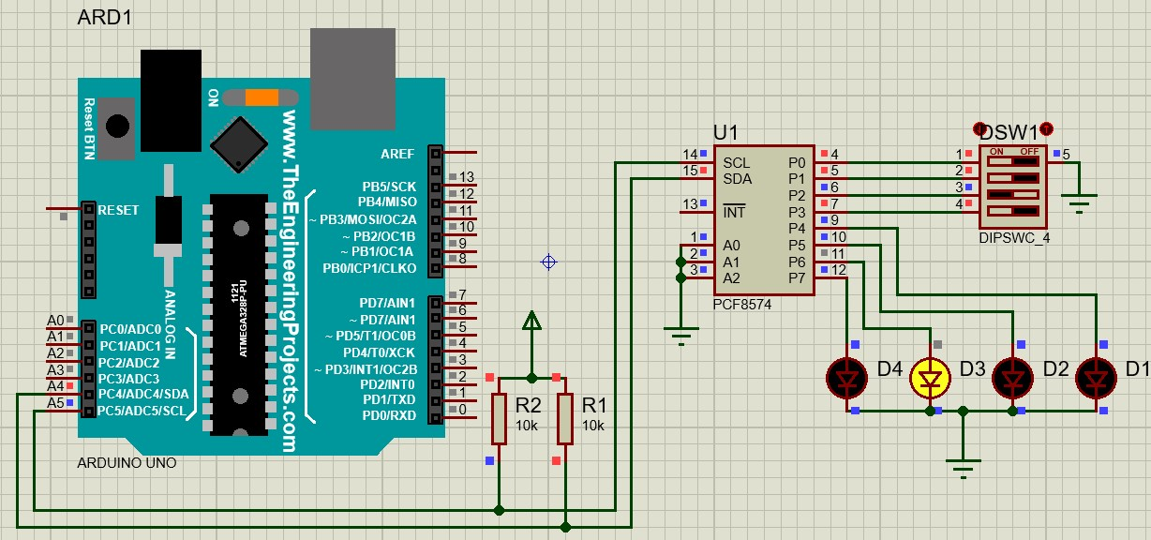  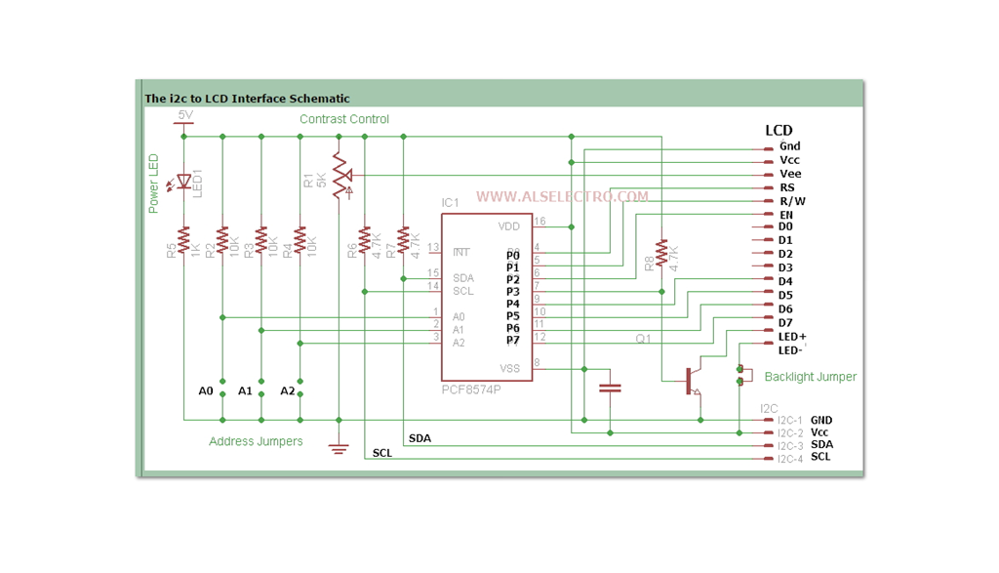  Below figure only for the I2C LCD
15. I2C RTC Program (Serial Print) :-  #include<avr/io.h> /* Page - 1 */  void i2c_init (void){  TWSR = 0X00; // set prescaler bits to zero  TWBR = 0x47; // SCL frequency is 50K for XTAL = 8Mhz  TWCR = 0x04; // enable TWI module  }  void i2c_start(void){  TWCR = ( 1 << TWINT ) | ( 1 << TWSTA ) | ( 1 << TWEN );  while ((TWCR & ( 1 << TWINT ) ) == 0) ;  }  void i2c_write(unsigned char data){  TWDR = data ;  TWCR = (1<<TWINT) | (1<<TWEN); // enable the transmission  while ((TWCR & ( 1 << TWINT ) ) == 0);  }  unsigned char i2c_read(unsigned char last){  if ( last == 0 ) // If want to read more than 1 byte  TWCR = (1<<TWINT) | (1<<TWEN) | (1<<TWEA);  else // else read only one byte  TWCR = (1<<TWINT) | (1<<TWEN);  while ((TWCR & ( 1 << TWINT ) ) == 0);  return TWDR ;  }  void i2c_stop(){  TWCR = ( 1 <<TWINT )|( 1 << TWEN) | ( 1<< TWSTO);  }  //-----------------------------------------------------  volatile uint8_t read_second(){  volatile uint8_t sec, second_ones, second_tens;  i2c_start();  i2c_write(0b11010000); // slave address + write  i2c_write(0x00); // second address 0x00  i2c_start(); // repeated start  i2c_write(0b11010001); // slave address + read  sec = i2c_read(1);  i2c_stop();  second_ones = 0x0f & sec;  second_tens = 0x07 & (sec >> 4);  sec = (second_tens * 10) + second_ones; // calculating the atual second value  return sec;  }  i2c_start(); /* Page - 3 */  i2c_write(0b11010000); // slave address + write  i2c_write(0x04); // date address 0x04  i2c_start(); // repeated start  i2c_write(0b11010001); // slave address + read  date = i2c_read(1);  i2c_stop();  date_ones = 0x0f & date;  date_tens = 0x03 & (date >> 4);  date = (date_tens * 10) + date_ones; // calculating the atual date value  return date;  }  volatile uint8_t read_month(){  volatile uint8_t month, month_ones, month_tens;  i2c_start();  i2c_write(0b11010000); // slave address + write  i2c_write(0x05); // month address 0x05  i2c_start(); // repeated start  i2c_write(0b11010001); // slave address + read  month = i2c_read(1);  i2c_stop();  month_ones = 0x0f & month;  month_tens = 0x01 & (month >> 4);  month = (month_tens * 10) + month_ones; // calculating the atual month value  return month;  }  volatile uint8_t read_year(){  volatile uint8_t year, year_ones, year_tens;  i2c_start();  i2c_write(0b11010000); // slave address + write  i2c_write(0x06); // year address 0x06  i2c_start(); // repeated start  i2c_write(0b11010001); // slave address + read  year = i2c_read(1);  i2c_stop();  year_ones = 0x0f & year;  year_tens = year >> 4;  year = (year_tens * 10) + year_ones; // calculating the atual year value  return year;  }  int main(){  Serial.begin(9600);  volatile uint8_t seconds, minutes, hours, days, dates, months, years; | volatile uint8_t read_minute(){ /* Page - 2 */  volatile uint8_t minute, minute_ones, minute_tens;  i2c_start();  i2c_write(0b11010000); // slave address + write  i2c_write(0x01); // minute address 0x01  i2c_start(); // repeated start  i2c_write(0b11010001); // slave address + read  minute = i2c_read(1);  i2c_stop();  minute_ones = 0x0f & minute;  minute_tens = minute >> 4;  minute = (minute_tens * 10) + minute_ones; // calculating the atual minute value  return minute;  }  volatile uint8_t read_hour(){  volatile uint8_t hour, hour_ones, hour_tens;  i2c_start();  i2c_write(0b11010000); // slave address + write  i2c_write(0x02); // hour address 0x02  i2c_start(); // repeated start  i2c_write(0b11010001); // slave address + read  hour = i2c_read(1);  i2c_stop();  hour_ones = 0x0f & hour;  hour_tens = 0x03 & (hour >> 4);  hour = (hour_tens * 10) + hour_ones; // calculating the atual hour value  return hour;  }  volatile uint8_t read_day(){  volatile uint8_t day;  i2c_start();  i2c_write(0b11010000); // slave address + write  i2c_write(0x03); // day address 0x03  i2c_start(); // repeated start  i2c_write(0b11010001); // slave address + read  day = i2c_read(1);  i2c_stop();  day &= 0x07; // calculating the atual day value  return day;  }  volatile uint8_t read_date(){  volatile uint8_t date, date_ones, date_tens;  char day[][12] = {"Saturday", "Sunday", "Monday", "Tuesday", "Wednessday", "Thursday", "Friday"};  i2c_init(); /* Page - 4 */  while(1){  Serial.print("TIME:- "); // printing the time //  hours = read_hour();  Serial.print(hours);  Serial.print(':');  minutes = read_minute();  Serial.print(minutes);  Serial.print(':');  seconds = read_second();  Serial.print(seconds);  Serial.println();  Serial.print("DATE:- "); // printing the date //  dates = read_date();  Serial.print(dates);  Serial.print('/');  months = read_month();  Serial.print(months);  Serial.print('/');  years = read_year();  Serial.print("20");  Serial.print(years);  Serial.println();  Serial.print("DAY:- "); // printing the day //  days = read_day();  Serial.print(day[days]);  Serial.println();  Serial.println();  Serial.println();  for(volatile long i=0; i<100000; i++); // delay //  }  return 0;  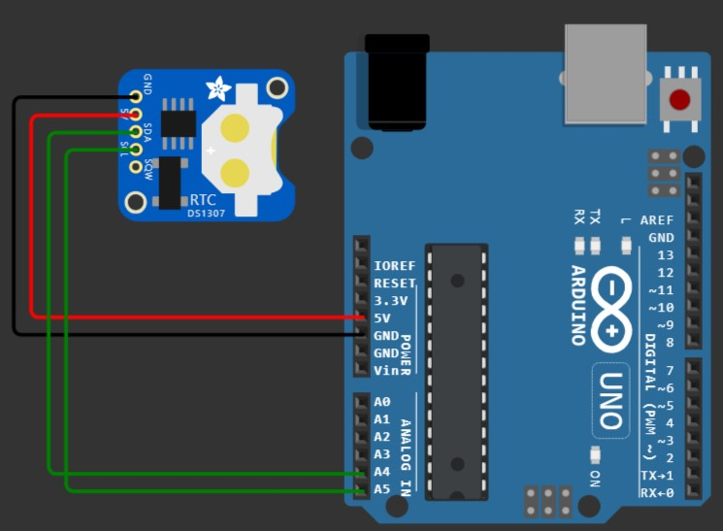  }

16. I2C RTC with I2C 16*2 LCD Program :-  #include "I2C.h" // Page 1 //  #include "LCD1602.h"  #include "RTC1307.h"  int main(){  volatile uint8_t seconds, minutes, hours, days, dates, months, years;  char day[][12] = {" Sunday", " Monday", " Tuesday", " Wednessday", " Thursday", " Friday", " Saturday",};  i2c_init();  lcd_init();  while(1){  for(volatile long i=0; i<300; i++){ // printing the Time & Date for a particular time //  lcd_cursor(0,0);  lcd_string("TIME-");  hours = read_hour(); // for reading the hour  lcd_number(hours); // for printing the hour  lcd_string(":");  minutes = read_minute(); // for reading the minute  lcd_number(minutes); // for printing the minute  lcd_string(":");  seconds = read_second(); // for reading the second  lcd_number(seconds); // for printing the second  lcd_string(" ");  lcd_cursor(1,0);  lcd_string("DATE-");  dates = read_date(); // for reading the date  lcd_number(dates); // for printing the date  lcd_string("/");  months = read_month(); // for reading the month  lcd_number(months); // for printing the month  lcd_string("/");  years = read_year(); // for reading the year  lcd_number(20);  lcd_number(years); // for printing the year  lcd_string(" ");  }  lcd_clear();  lcd_cursor(0,0);  lcd_string("Today is:-");  lcd_cursor(1,0);  days = read_day(); // for reading the day  lcd_string(day[days - 1]); // for printing the day  lcd_string(" ");  for(volatile long i=0; i<1000000; i++); // delay //  }  return 0;  } | # I2C.h (header file) #  #include<avr/io.h> // Page 2 //  void i2c_init (void){  TWSR = 0X00; // set prescaler bits to zero  TWBR = 0x47; // SCL frequency is 50K for XTAL = 8Mhz  TWCR = 0x04; // enable TWI module  }  void i2c_start(void){  TWCR = ( 1 << TWINT ) | ( 1 << TWSTA ) | ( 1 << TWEN );  while ((TWCR & ( 1 << TWINT ) ) == 0) ;  }  void i2c_write(unsigned char data){  TWDR = data ;  TWCR = (1<<TWINT) | (1<<TWEN); // enable the transmission  while ((TWCR & ( 1 << TWINT ) ) == 0);  }  unsigned char i2c_read(unsigned char last){  if ( last == 0 ) // If want to read more than 1 byte  TWCR = (1<<TWINT) | (1<<TWEN) | (1<<TWEA);  else // else read only one byte  TWCR = (1<<TWINT) | (1<<TWEN);  while ((TWCR & ( 1 << TWINT ) ) == 0);  return TWDR ;  }  void i2c_stop(){  TWCR = ( 1 <<TWINT )|( 1 << TWEN) | ( 1<< TWSTO);  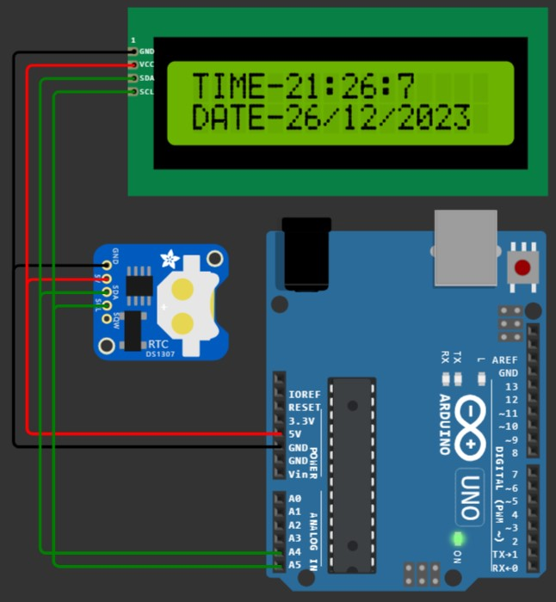  }
# RTC1307.h (header file) #  volatile uint8_t read_second(){ // Page 3 //  volatile uint8_t sec, second_ones, second_tens;  i2c_start();  i2c_write(0b11010000); // slave address + write  i2c_write(0x00); // second address 0x00  i2c_start(); // repeated start  i2c_write(0b11010001); // slave address + read  sec = i2c_read(1);  i2c_stop();  second_ones = 0x0f & sec;  second_tens = 0x07 & (sec >> 4);  sec = (second_tens * 10) + second_ones; // calculating the actual second value  return sec;  }  volatile uint8_t read_minute(){  volatile uint8_t minute, minute_ones, minute_tens;  i2c_start();  i2c_write(0b11010000); // slave address + write  i2c_write(0x01); // minute address 0x01  i2c_start(); // repeated start  i2c_write(0b11010001); // slave address + read  minute = i2c_read(1);  i2c_stop();  minute_ones = 0x0f & minute;  minute_tens = minute >> 4;  minute = (minute_tens * 10) + minute_ones; // calculating the actual minute value  return minute;  }  volatile uint8_t read_hour(){  volatile uint8_t hour, hour_ones, hour_tens;  i2c_start();  i2c_write(0b11010000); // slave address + write  i2c_write(0x02); // hour address 0x02  i2c_start(); // repeated start  i2c_write(0b11010001); // slave address + read  hour = i2c_read(1);  i2c_stop();  hour_ones = 0x0f & hour;  hour_tens = 0x03 & (hour >> 4);  hour = (hour_tens * 10) + hour_ones; // calculating the actual hour value  return hour;  }  volatile uint8_t read_day(){  volatile uint8_t day;  i2c_start();  i2c_write(0b11010000); // slave address + write  i2c_write(0x03); // day address 0x03  i2c_start(); // repeated start | i2c_write(0b11010001); // slave address + read  day = i2c_read(1);  i2c_stop(); // Page 4 //  day &= 0x07; // calculating the actual day value  return day;  }  volatile uint8_t read_date(){  volatile uint8_t date, date_ones, date_tens;  i2c_start();  i2c_write(0b11010000); // slave address + write  i2c_write(0x04); // date address 0x04  i2c_start(); // repeated start  i2c_write(0b11010001); // slave address + read  date = i2c_read(1);  i2c_stop();  date_ones = 0x0f & date;  date_tens = 0x03 & (date >> 4);  date = (date_tens * 10) + date_ones; // calculating the actual date value  return date;  }  volatile uint8_t read_month(){  volatile uint8_t month, month_ones, month_tens;  i2c_start();  i2c_write(0b11010000); // slave address + write  i2c_write(0x05); // month address 0x05  i2c_start(); // repeated start  i2c_write(0b11010001); // slave address + read  month = i2c_read(1);  i2c_stop();  month_ones = 0x0f & month;  month_tens = 0x01 & (month >> 4);  month = (month_tens * 10) + month_ones; // calculating the actual month value  return month;  }  volatile uint8_t read_year(){  volatile uint8_t year, year_ones, year_tens;  i2c_start();  i2c_write(0b11010000); // slave address + write  i2c_write(0x06); // year address 0x06  i2c_start(); // repeated start  i2c_write(0b11010001); // slave address + read  year = i2c_read(1);  i2c_stop();  year_ones = 0x0f & year;  year_tens = year >> 4;  year = (year_tens * 10) + year_ones; // calculating the actual year value  return year;  }

# lcd1602.h (header file) #  void send_command(volatile uint8_t cmd); // Page 5 //  #define command_en_high 4 + 8 // RS=0, R/W=0, EN=1 (4), LED+ = 1 (8)  #define command_en_low 0 + 8 // RS=0, R/W=0, EN=0, LED+ = 1 (8)  #define data_en_high 1 + 4 + 8 // RS=1 (1), R/W=0, EN=1 (4), LED+ = 1 (8)  #define data_en_low 1 + 8 // RS=1 (1), R/W=0, EN=0, LED+ = 1 (8)  #define slave_address 0x27 << 1 // slave address of the I2C LCD  void lcd_init(){  send_command (0x02); // 4bit mode  //send_command (0x28); // 4bit mode  send_command (0x0C); // Display ON Cursor OFF  send_command (0x06); // Auto Increment cursor  send_command (0x01); // Clear display  send_command (0x80); // Cursor at home position  }  void send_command(volatile uint8_t cmd){  volatile uint8_t high_nibble = cmd & 0xf0;  volatile uint8_t low_nibble = cmd << 4;  i2c_start(); // transmit start  i2c_write(slave_address); // transmitt Slave address + W0 (SLA+W means to master is writing )  i2c_write(high_nibble + command_en_high);  i2c_write(high_nibble + command_en_low);  i2c_write(low_nibble + command_en_high);  i2c_write(low_nibble + command_en_low);  i2c_stop(); // transmit stop condition  delayMicroseconds(50);  }  void send_data(volatile uint8_t data1){  volatile uint8_t high_nibble = data1 & 0xf0;  volatile uint8_t low_nibble = data1 << 4;  i2c_start(); // transmit start  i2c_write(slave_address); // transmitt Slave address + W0 (SLA+W means to master is writing )  i2c_write(high_nibble + data_en_high);  i2c_write(high_nibble + data_en_low);  i2c_write(low_nibble + data_en_high);  i2c_write(low_nibble + data_en_low);  i2c_stop(); // transmitt stop condition  delayMicroseconds(50);  } | void lcd_string (char *str){ // Page 6 //  int i;  for(i=0;str[i]!=0;i++)  send_data (str[i]); /* Call LCD data write */  }  void lcd_number(volatile uint16_t number){  volatile char i=0, num[8]={0};  while(number){  num[i++] = number%10;  number/=10;  }  i--;  for(; i>=0; i--)  send_data(num[i] + 48);  }  void lcd_cursor(volatile uint8_t row, volatile uint8_t column){  if(row==0) send_command(0x80 + column);  else if(row==1) send_command(0xc0 + column);  }  void lcd_clear(){  send_command(0x01);  }  
-: SPI Protocol :-
01. SPI General Program (Master) :-  [CPOL=1, CPHA=1]  void SPI_MasterInit(void){  DDRB = 0x2c; // SCK, MOSI, SS set as Output & MISO as Input  PORTB |= 0x04; // Make SS pin High  SPCR |= (1<<SPE) | (1<<MSTR) | (1<<CPOL) | (1<<CPHA) | (1<<SPR0);  }  void SPI_MasterTransmit(volatile uint8_t cData){  SPDR = cData;  PORTB &= ~0x04; // Make SS pin Low  while(!(SPSR & (1<<SPIF))); // Wait until the Serial Transfer is completed  PORTB |= 0x04; // Make SS pin High  delayMicroseconds(2);  }  void setup(){  SPI_MasterInit();  SPI_MasterTransmit(0x55);  }  void loop(){} | (Slave) :-  void SPI_SlaveInit(void)  {  DDRB = 0x10; // MISO set as Output & SCK, MOSI, SS as Input  SPCR |= (1<<SPE) | (1<<CPOL) | (1<<CPHA);  }  char SPI_SlaveReceive(void)  {  while(!(SPSR & (1<<SPIF))); // Wait until the Serial Transfer is completed  return SPDR;  }  void setup(){  DDRD = 0xff; // Set Port D as Output  SPI_SlaveInit();  PORTD = SPI_SlaveReceive();  }  void loop(){}

Only Master to Slave Transmission
(Half Duplex)

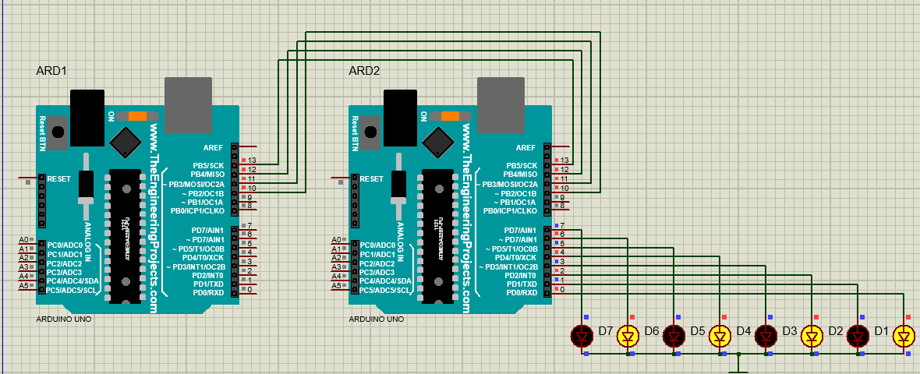

02. SPI General Program (Master) :-  [CPOL=0, CPHA=0]  void SPI_MasterInit(void){  DDRB = 0x2c; // SCK, MOSI, SS set as Output & MISO as Input  PORTB |= 0x04; // Make SS pin High  SPCR |= (1<<SPE) | (1<<MSTR) | (1<<SPR0);  }  void SPI_MasterTransmit(volatile uint8_t cData){  SPDR = cData;  PORTB &= ~0x04; // Make SS pin Low  while(!(SPSR & (1<<SPIF))); // Wait until the Serial Transfer is completed  PORTB |= 0x04; // Make SS pin High  delayMicroseconds(2);  }  void setup(){  SPI_MasterInit();  SPI_MasterTransmit(0x55);  }  void loop(){} | (Slave) :-  void SPI_SlaveInit(void){  DDRB = 0x10; // MISO set as Output & SCK, MOSI, SS as Input  SPCR |= (1<<SPE);  }  char SPI_SlaveReceive(void){  while(!(SPSR & (1<<SPIF))); // Wait until the Serial Transfer is completed  return SPDR;  }  void setup(){  DDRD = 0xff; // Set Port D as Output  SPI_SlaveInit();  PORTD = SPI_SlaveReceive();  }  void loop(){}
03. SPI LED Shift Program (Master) :-  void SPI_MasterInit(void){  DDRB = 0x2c; // SCK, MOSI, SS set as Output  PORTB |= 0x04; // Make SS pin High  SPCR |= (1<<SPE) | (1<<MSTR) | (1<<SPR0);  }  void SPI_MasterTransmit(volatile uint8_t cData){  SPDR = cData;  PORTB &= ~0x04; // Make SS pin Low  while(!(SPSR & (1<<SPIF)));  PORTB |= 0x04; // Make SS pin High  delayMicroseconds(2);  }  void setup(){  volatile uint8_t shift=0;  SPI_MasterInit();  while(1){  SPI_MasterTransmit(3<<shift);  shift++;  if(shift==8) shift=0;  for(volatile long i=0; i<100000; i++);  }}  void loop(){} | (Slave) :-  void SPI_SlaveInit(void){  DDRB = 0x10; // MISO set as Output & SCK, MOSI, SS as Input  SPCR |= (1<<SPE);  }  char SPI_SlaveReceive(void){  while(!(SPSR & (1<<SPIF))); // Wait until the Serial Transfer is completed  return SPDR;  }  void setup(){  DDRD = 0xff; // Set Port D as Output  SPI_SlaveInit();  while(1) PORTD = SPI_SlaveReceive();  }  void loop(){}
04. SPI LED Program [Full Duplex] (Master) :-  void SPI_MasterInit(void){  DDRB = 0x2c; // SCK, MOSI, SS set as Output & MISO as Input  PORTB |= 0x04; // Make SS pin High  SPCR |= (1<<SPE) | (1<<MSTR) | (1<<SPR0);  }  void SPI_MasterTransmit(volatile uint8_t cData){  SPDR = cData;  PORTB &= ~0x04; // Make SS pin Low  while(!(SPSR & (1<<SPIF))); // Wait until the Serial Transfer is completed  PORTB |= 0x04; // Make SS pin High  }  char SPI_MasterReceive(void){  while(!(SPSR & (1<<SPIF))); // Wait until the Serial Transfer is completed  return SPDR;  }  void setup(){  DDRD = 0xff;  SPI_MasterInit();  while(1){  SPI_MasterTransmit(0x50);  PORTD = SPI_MasterReceive();  }  }  void loop(){} | (Slave) :-  void SPI_SlaveInit(void){  DDRB = 0x10; // MISO set as Output & SCK, MOSI, SS as Input  SPCR |= (1<<SPE);  }  char SPI_SlaveReceive(void){  while(!(SPSR & (1<<SPIF))); // Wait until the Serial Transfer is completed  return SPDR;  }  void SPI_SlaveTransmit(volatile uint8_t cData){  SPDR = cData;  while(!(SPSR & (1<<SPIF))); // Wait until the Serial Transfer is completed  //delayMicroseconds(2);  }  void setup(){  DDRD = 0xff; // Set Port D as Output  SPI_SlaveInit();  while(1) {  PORTD = SPI_SlaveReceive();  SPI_SlaveTransmit(0x03);  }  }  void loop(){}

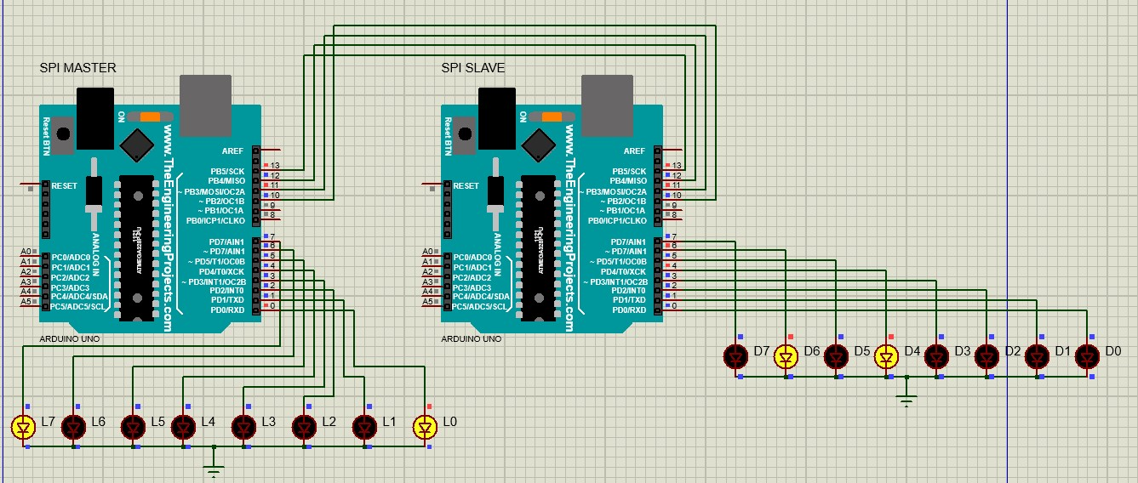
In real hardware, this program works fine but in Proteus, the Master receives wrong data, Ex – The Slave send data 0x03 but the Master receives 0x81 as shown in the figure.
Master to Slave & Vice-Versa (Full Duplex)
Master to Slave & vice-versa
(Full Duplex)

05. SPI Keyboard & LCD Program (Master) :-  //---------------------------------- SPI Functions -------------------------------//  void SPI_MasterInit(void){  DDRB = 0x2c; // SCK, MOSI, SS set as Output & MISO as Input  PORTB |= 0x04; // Make SS pin High  SPCR |= (1<<SPE) | (1<<MSTR) | (1<<SPR0);  }  void SPI_MasterTransmit(volatile uint8_t cData){  SPDR = cData;  PORTB &= ~0x04; // Make SS pin Low  while(!(SPSR & (1<<SPIF))); // Wait until the Serial Transfer is completed  PORTB |= 0x04; // Make SS pin High  }  char SPI_MasterReceive(void){  while(!(SPSR & (1<<SPIF))); // Wait until the Serial Transfer is completed  return SPDR;  }  //------------------- KEYBOARD SCANNING FUNCTION ----------------------//  volatile char checkKey(){  volatile char row, col, key;  for(row=0; row<4; row++){  PORTC = 1 << row;  if(PIND){ col=(PIND) >> 4; break;}  }  if(row==0){  if(col==1) key='7';  else if(col==2) key='8';  else if(col==4) key='9';  else if(col==8) key='/';  }  else if(row==1){  if(col==1) key='4';  else if(col==2) key='5';  else if(col==4) key='6';  else if(col==8) key='*';  }  else if(row==2){  if(col==1) key='1';  else if(col==2) key='2';  else if(col==4) key='3';  else if(col==8) key='-';  } | (Slave) :-  //------------------------------- SPI Functions -----------------------------//  void SPI_SlaveInit(void){  DDRB = 0x10; // MISO set as Output & SCK, MOSI, SS as Input  SPCR |= (1<<SPE);  }  char SPI_SlaveReceive(void){  while(!(SPSR & (1<<SPIF))); // Wait until the Serial Transfer is completed  return SPDR;  }  //------------------------------- LCD Functions ----------------------------//  void LCD_Init (void)  {  LCD_Command (0x02); // 8bit mode  LCD_Command (0x28); // 8bit mode  LCD_Command (0x0C); //Display ON Cursor OFF  LCD_Command (0x06); // Auto Increment cursor  LCD_Command (0x01); // Clear display  LCD_Command (0x80); // Cursor at home position  delayMicroseconds(2000);  }  void LCD_Command (volatile uint8_t cmnd)  {  PORTD = (cmnd & 0xf0) + 4; /* Send upper nibble */  delayMicroseconds(50);  PORTD &= ~4;  delayMicroseconds(50);  PORTD = (cmnd << 4) + 4; /* Send lower nibble */  delayMicroseconds(50);  PORTD &= ~4;  delayMicroseconds(50);  }  void LCD_Data (volatile uint8_t data)  {  PORTD = (data & 0xf0) + 12; /* Send upper nibble */  delayMicroseconds(50);  PORTD &= ~4;  delayMicroseconds(50);  PORTD = (data << 4) + 12; /* Send lower nibble */  delayMicroseconds(50);  PORTD &= ~4;  delayMicroseconds(50);  }

else if(row==3){  if(col==1) key='c';  else if(col==2) key='0';  else if(col==4) key='=';  else if(col==8) key='+';  }  else key=0;  return key;  }  //----------------------------------- Main Function ----------------------------//  void setup(){  DDRD = 0;  DDRC = 0x0F;  volatile char send_data;  SPI_MasterInit();  while(1){  send_data = checkKey();  if(send_data) SPI_MasterTransmit(send_data);  for(volatile long i=0; i<70000; i++);  }  } | //------------------------------ Main Function ----------------------------//  void setup(){  DDRD = 0xff;  DDRC = 0x0f;  volatile uint8_t data;  SPI_SlaveInit();  LCD_Init(); /* Initialization of LCD*/  while(1){  data = SPI_SlaveReceive();  if(data=='c') LCD_Command(0x01); // clear the display  else LCD_Data(data); // print the data  }  }
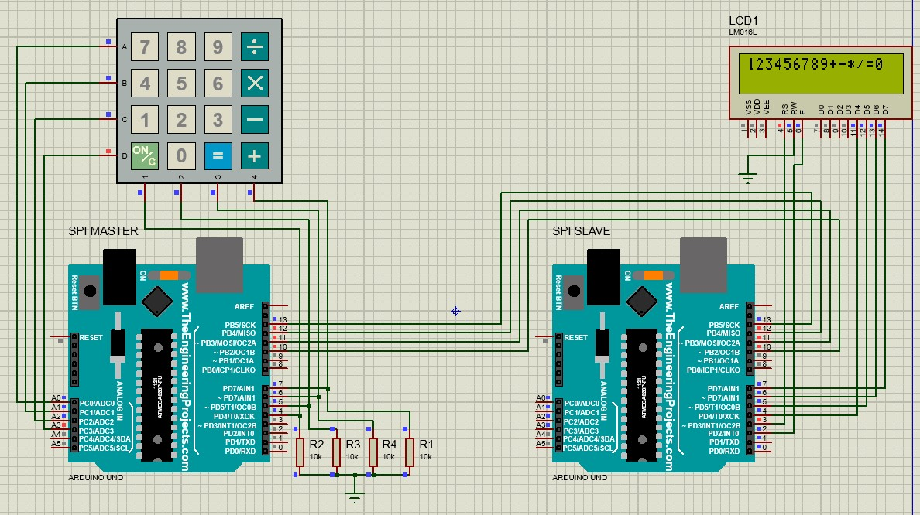
ON/C - for clear the display

-: USART Protocol :-
/* 01. UART Transmitter Code (Sending ‘A’) */  void init_USART0(){  volatile uint16_t UBRR_value = 103; // UBBR0 = ((clock frequency/(16*baud rate)) - 1)  // UBBR0 = ((16,000,000/(16*9600)) -1) = 103  UBRR0H = (unsigned char)(UBRR_value >> 8);  UBRR0L = (unsigned char) UBRR_value; // Select the 9600 baud rate  UCSR0B = (1 << RXEN0) | (1 << TXEN0); // enable Tx and Rx  UCSR0C = (1 << USBS0) | (3 << UCSZ00); // set 2 stop bit & 8 data bit  }  void setup() {  DDRD &= ~4; // set port-D 2nd pin as Input  DDRB = 1; // set port-B 0th pin as Output  init_USART0();  while(1){  if((PIND & 4)==0){  PORTB ^= 1;  while(!(UCSR0A & (1 << UDRE0))); // wait untill the UDRE0 bit is set  UDR0 = 65; // 65 = A  for(volatile long i=0; i<100000; i++); // switch debouncing delay  }  }  }  void loop() {} | /* UART Receiver Code */  void init_USART0(){  volatile uint16_t UBRR_value = 103; // UBBR0 = ((clock frequency/(16*baud rate)) - 1)  // UBBR0 = ((16,000,000/(16*9600)) -1) = 103  UBRR0H = (unsigned char)(UBRR_value >> 8);  UBRR0L = (unsigned char) UBRR_value; // Select the 9600 baud rate  UCSR0B = (1 << RXEN0) | (1 << TXEN0); // enable Tx and Rx  UCSR0C = (1 << USBS0) | (3 << UCSZ00); // set 2 stop bit & 8 data bit  }  void setup() {  DDRB = 1; // port-B 0th bit set as Output  init_USART0();  volatile uint8_t receive_data;  while(1){  while(!(UCSR0A & (1 << RXC0))); // wait until the RXC0 bit is set  receive_data = UDR0;  if(receive_data == 'A'){  PORTB ^= 1;  }  }  }  void loop() {}
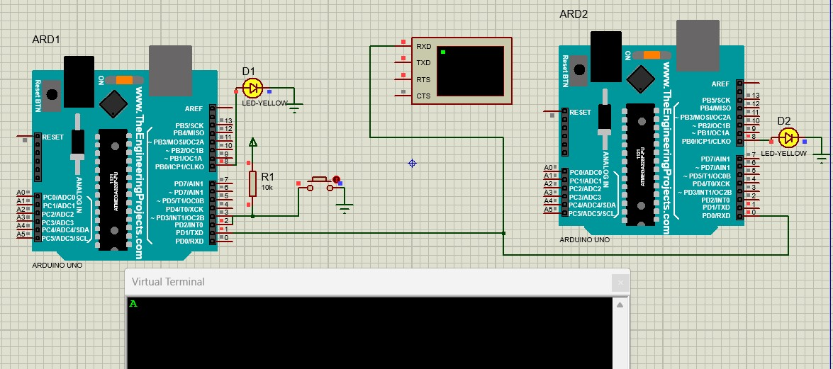

/* 02. UART Transmit and Receive using Rx complete interrupt (Transmitter Code) */  volatile uint8_t receive_data;  void init_USART0(){  volatile uint16_t UBRR_value = 103; // UBBR0 = ((clock frequency/(16*baud rate)) - 1)  // UBBR0 = ((16,000,000/(16*9600)) -1) = 103  UBRR0H = (unsigned char)(UBRR_value >> 8);  UBRR0L = (unsigned char) UBRR_value; // Select the 9600 baud rate  UCSR0B = (1 << RXEN0) | (1 << TXEN0) | (1<<RXCIE0); // enable Tx, Rx and Rx complete interrupt  UCSR0C = (1 << USBS0) | (3 << UCSZ00); // set 2 stop bit & 8 data bit  }  void USART_send(volatile char data){  while(!(UCSR0A & (1 << UDRE0))); // wait untill the UDRE0 bit is set  UDR0 = data;  }  void setup() {  DDRD &= ~4; // set port-D 2nd pin as Input  DDRB = 1; // set port-B 0th pin as Output  init_USART0();  while(1){  if((PIND & 4)==0){  USART_send('A');  for(volatile long i=0; i<100000; i++); // switch debouncing delay  }  if(receive_data == 'B'){  PORTB ^= 1;  receive_data=0;  }  }  }  ISR(USART_RX_vect){  receive_data = UDR0;  } | /* Receiver Code */  volatile uint8_t receive_data;  void init_USART0(){  volatile uint16_t UBRR_value = 103; // UBBR0 = ((clock frequency/(16*baud rate)) - 1)  // UBBR0 = ((16,000,000/(16*9600)) -1) = 103  UBRR0H = (unsigned char)(UBRR_value >> 8);  UBRR0L = (unsigned char) UBRR_value; // Select the 9600 baud rate  UCSR0B = (1 << RXEN0) | (1 << TXEN0) | (1<<RXCIE0); // enable Tx, Rx and Rx complete interrupt  UCSR0C = (1 << USBS0) | (3 << UCSZ00); // set 2 stop bit & 8 data bit  }  void USART_send(volatile char data){  while(!(UCSR0A & (1 << UDRE0))); // wait untill the UDRE0 bit is set  UDR0 = data;  }  void setup() {  DDRD &= ~4; // set port-D 2nd pin as Input  DDRB = 1; // port-B 0th bit set as Output  init_USART0();  while(1){  if((PIND & 4)==0){  USART_send('B');  for(volatile long i=0; i<100000; i++); // switch debouncing delay  }  if(receive_data == 'A'){  PORTB ^= 1;  receive_data=0;  }  }  }  ISR(USART_RX_vect){  receive_data = UDR0;  }
This figure is the circuit diagram of the above code
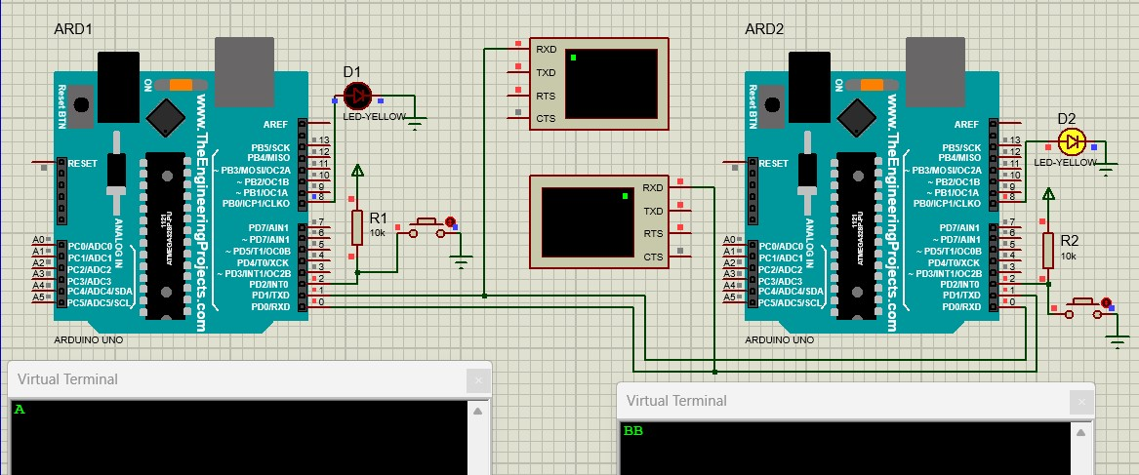

/* UART Transmitter Code */  void init_USART0(){  volatile uint16_t UBRR_value = 103; // UBBR0 = ((clock frequency/(16*baud rate)) - 1)  // UBBR0 = ((16,000,000/(16*9600)) -1) = 103  UBRR0H = (unsigned char)(UBRR_value >> 8);  UBRR0L = (unsigned char) UBRR_value; // Select the 9600 baud rate  UCSR0B = (1 << RXEN0) | (1 << TXEN0); // enable Tx and Rx  UCSR0C = (1 << USBS0) | (3 << UCSZ00); // set 2 stop bit & 8 data bit  }  void setup() {  DDRD &= ~4; // set port-D 2nd pin as Input  DDRB = 1; // set port-B 0th pin as Output  init_USART0();  while(1){  if((PIND & 4)==0){  PORTB ^= 1;  while(!(UCSR0A & (1 << UDRE0))); // wait untill the UDRE0 bit is set  UDR0 = 'A';  for(volatile long i=0; i<100000; i++); // switch debouncing delay  }  }  }  void loop() {} | 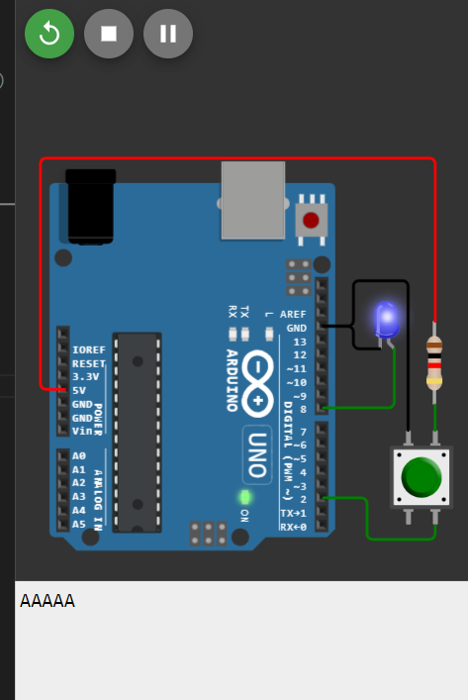

-: USART Protocol in SPI Mode :-
/* Master Code (only Master generates the clock (in XCK pin)) [Simple LED Output] using USART Rx interrupt */  volatile char receive_data;  void USART_Init(){  UBRR0 = 0;  DDRD |= 16; // XCK pin (i.e - PD4) set as output  UCSR0C = (1<<UMSEL01)|(1<<UMSEL00)|(1<<UCPHA0)|(1<<UCPOL0);  UCSR0B = (1<<RXEN0)|(1<<TXEN0)|(1<<RXCIE0); // Enable Tx, Rx & Recive complete interrupt  UBRR0 = 832; // set baud rate as 9600  }  void USART_Transmit(volatile char data){  while (!(UCSR0A & (1<<UDRE0))); // Wait for empty transmit buffer  UDR0 = data;  }  void setup(){  DDRB = 0x0f;  USART_Init();  while(1){  USART_Transmit(0x0C);  if(receive_data){  PORTB = receive_data;  receive_data = 0;  }  }  }  ISR(USART_RX_vect){  receive_data = UDR0;  } | /* Slave Code [Simple LED Output]*/  volatile char receive_data;  void USART_Init(){  UBRR0 = 0;  DDRD &= ~16; // XCK pin (i.e - PD4) set as Input as slave  UCSR0C = (1<<UMSEL01)|(1<<UMSEL00)|(1<<UCPHA0)|(1<<UCPOL0);  UCSR0B = (1<<RXEN0)|(1<<TXEN0)|(1<<RXCIE0); // Enable Tx, Rx & Recive complete interrupt  UBRR0 = 832; // set baud rate as 9600  }  void USART_Transmit(volatile char data){  while (!(UCSR0A & (1<<UDRE0))); // Wait for empty transmit buffer  UDR0 = data;  }  void setup(){  DDRB = 0x0f;  USART_Init();  while(1){  USART_Transmit(0x03);  if(receive_data){  PORTB = receive_data;  receive_data = 0;  }  }  }  ISR(USART_RX_vect){  receive_data = UDR0;  }
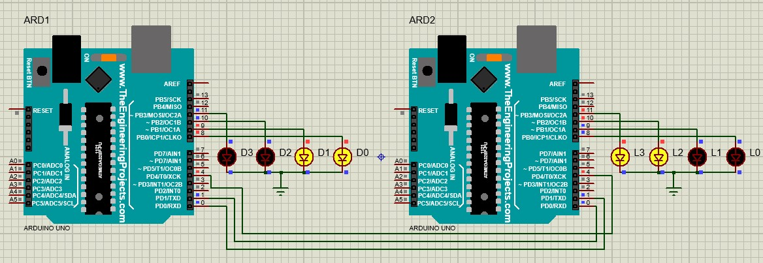

/* This is the same code as above but without interrupt Master Code */  void USART_Init()  {  UBRR0 = 0;  DDRD |= 16;  UCSR0C = (1<<UMSEL01)|(1<<UMSEL00)|(1<<UCPHA0)|(1<<UCPOL0);  UCSR0B = (1<<RXEN0)|(1<<TXEN0);  UBRR0 = 832;  }  volatile char USART_Tx_Rx(volatile char data){  while (!(UCSR0A & (1<<UDRE0))); /* Wait for empty transmit buffer */  UDR0 = data;  while (!(UCSR0A & (1<<RXC0))); /* Wait for data to be received */  return UDR0;  }  void setup(){  DDRB = 0xff;  USART_Init();  while(1){  PORTB = USART_Tx_Rx(0x05);  }  } | /* Slave Code */  void USART_Init(){  UBRR0 = 0;  DDRD |= 16;  UCSR0C = (1<<UMSEL01)|(1<<UMSEL00)|(1<<UCPHA0)|(1<<UCPOL0);  UCSR0B = (1<<RXEN0)|(1<<TXEN0);  UBRR0 = 832;  }  volatile char USART_Tx_Rx(volatile char data){  while (!(UCSR0A & (1<<UDRE0))); /* Wait for empty transmit buffer */  UDR0 = data;  while (!(UCSR0A & (1<<RXC0))); /* Wait for data to be received */  return UDR0;  }  void setup(){  DDRB = 0xff;  USART_Init();  while(1){  PORTB = USART_Tx_Rx(0x03);  }  }
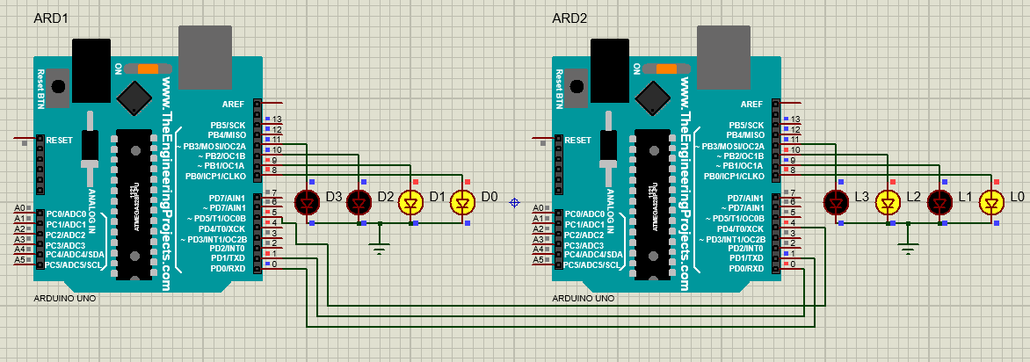

----------------------------- o ---------------------------

